1)Create web pages using Basic HTML Tags, Table, List, Image, and Frame Tags
HTML Tags:
Character formatting:
<html>
<head>
<title>Character tags</title>
</head>
<body bgcolor="pink">
</b><br><br>
/i><br><br>
<u>underline tag</u><br><br>
<big>Big tag</big><br><br>
<small>Small tag</small><br><br>
<strong>Strong tag</strong><br><br>
<sub>Qualification</sub><br><br>
<sup>x 2</sup><br><br>
</body>
</html>
OUTPUT:
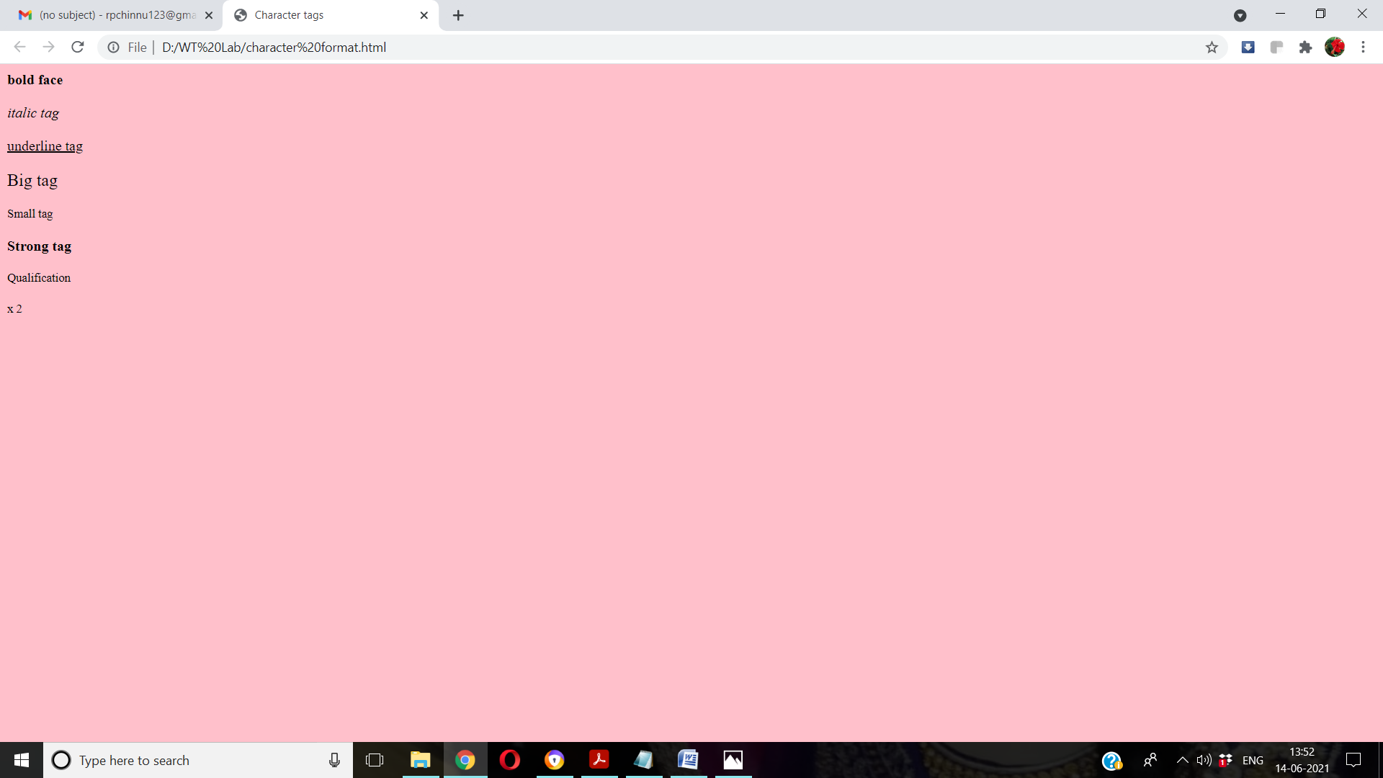

Block formatting:
<html>
<head>
<title>Bold Formatting</title>
</head>
<body bgcolor="pink"><br>
<p align="center">This is formatting</p>
<h1 align="left">This is h1</h1>
<h2 align="right">This is h2</h2>
<h3 align="center">This is h3</h3>
<h4>This is h4</h4>
<h5>This is h5</h5>
<h6 align="left">This is h6</h6>
<p>this is hr</p>
<hr align="center" size="10"/>
<basefont size="50">this is web</basefont>
<tt>Mary Ratnam</tt><br>
<PRE>this is aditya</PRE>
<marquee align="right">hii Ramavarapu</marquee>
<font face="Blackadder ITC" size="20" color="Green">This is wt lab</font>
</body>
</html>

OUTPUT:

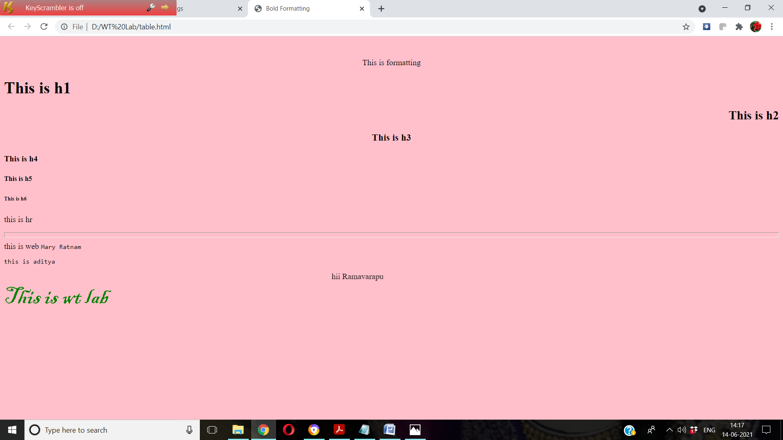

Table:
<html>
<head>
<title>table page</title>
</head>
<body bgcolor="pink">
<table align="left" cellpadding="2" cellspacing="2" border="3" bgcolor="cyan">
<tr>
<th colspan="4">Sample Table</th>
</tr>
<tr>
<th>HEAD1</th>
<td rowspan="3">CELL2</td>
<th>HEAD3</th>
<th>HEAD4</th>
<tr>
<td>CELL1</td>
<td>CELL3</td><td>CELL4</td>
</tr>
<tr>
<td>CELL5</td>
<td colspan="2" align="center">CELL6</td>
</tr>
</table>
</body>
</html>
OUTPUT:

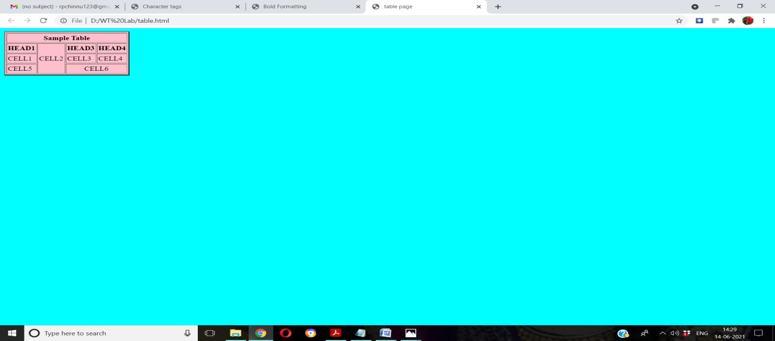

Lists:
Ordered list:
<html>
<head>
<title>Ordered lists</title>
</head>
<body>
<h4>Microsoft packages</h4>
<ol type="1">
<li>Wordpad
<li>PowerPoint
<li>Ms-Excel
</ol>
<h4>Lists</h4>
<ol type="A" start=25>
<li>ordered list
<li>unordered list
<li>nested list
</ol>
<h4>Scripting language</h4>
<ol type="I" start=4>
<li>java Script
<li>jscript
</ol>
<h4>Database application</h4>
<ol type="i" start=5>
<li>SQL
<li>Mysql
<li>Oracel
</ol>
</body>
</html>
OUTPUT:

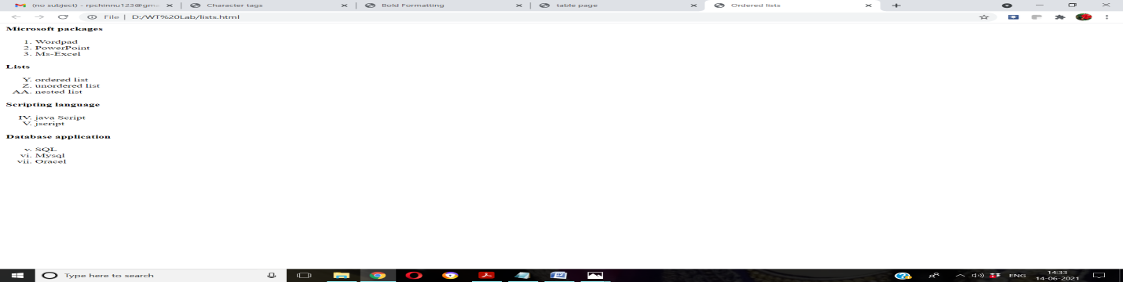

Unordered List:
<html>
<head>
<title>UnOrdered lists</title>
</head>
<body>
<h4>Microsoft packages</h4>
<ul>
<li>Wordpad
<li>PowerPoint
<li>Ms-Excel
</ul>
<h4>Lists</h4>
<ul type="square">
<li>ordered list
<li>unordered list
<li>nested list
</ul>
<h4>Scripting language</h4>
<ul type="disc">
<li>java Script
<li>jscript
</ul>
<h4>Database application</h4>
<ul type="circle">
<li>SQL
<li>Mysql 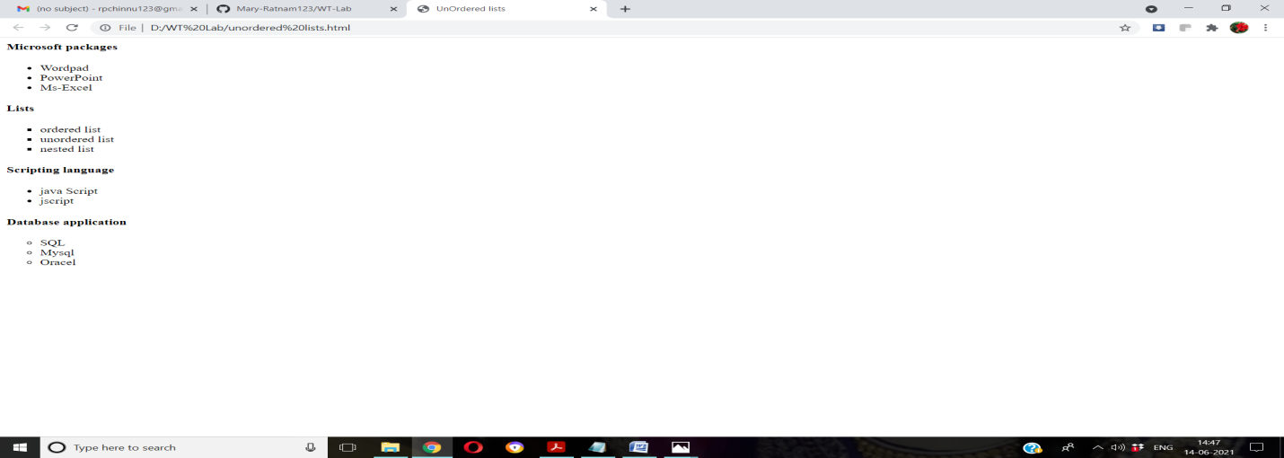
<li>Oracel
</ul>
</body>
</html>
OUTPUT:

Image:
<html>
<head>
<title>IMAGE Tags</title>
</head>
<body>
<center>
<img src="D:scenery.jpg"height=700$,width=100%>
</center>
</body>
</html>
OUTPUT:
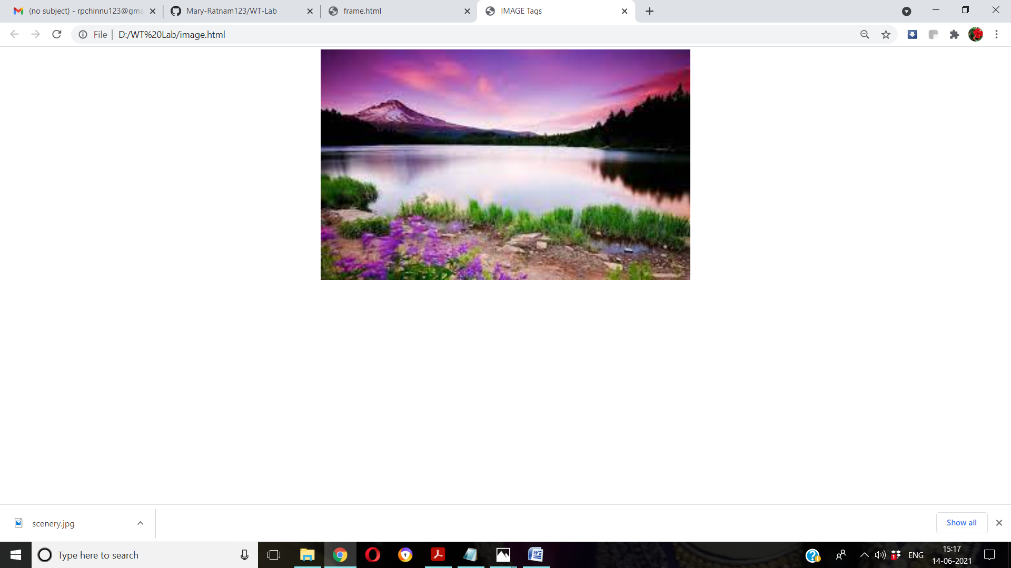

Frame:
First.html
<html>
<body bgcolor="cyan">
<font size=5> <p>This is first frame</p> </font>
</body>
</html>
Second.html
<html>
<body bgcolor="orange">
<font size=5> <p>This is second frame</p> </font>
</body>
</html>
Third.html
<html>
<body bgcolor="red">
<font size=5> <p>This is third frame</p> </font>
</body>
</html>
Forth.html
<html>
<body bgcolor="blue">
<font size=5> <p>This is forth frame</p> </font>
</body>
</html>
Frame.html
<frameset cols="40%,40%" rows="40%,40%">
<frame name="fr1" src="first.html" noresize scrolling="yes">
<frame name="fr2" src="second.html" noresize scrolling="yes">
<frame name="fr3" src="third.html" noresize scrolling="yes">
<frame name="fr4" src="forth.html" noresize scrolling="yes">
</frameset>

OUTPUT:

